Current press release, October 20, 2021
for immediate publication

FEFCO Technical Seminar, October 20-22, 2021
Bella Center, Copenhagen (Denmark)
Hunkeler Systeme AG, Booth A049

Increasing efficiency in corrugated cardboard disposal
Hunkeler Systeme AG develops and builds complete systems for the automated disposal of production waste in the manufacture of corrugated cardboard packaging. Outstanding features are a dust-free working environment and very low-energy, cost-effective operation. The systems are precisely tailored to user requirements.
With extraction, shredding and compaction technology, Hunkeler Systeme AG covers the entire workflow for waste disposal downstream of die cutters and corrugators in corrugated board processing. The interfaces from the die-cutting machine to the waste disposal system are set up according to user requirements and integrated into the existing technical structures. The space requirement of the complete disposal system is always kept to a minimum.
Hunkeler Systeme AG uses the negative pressure principle for its extraction technology. The fan is positioned at the very end of a line. This creates a suction effect in the entire piping system, ensuring that the dust-laden transport air cannot escape from the pipelines into the working environment. Jet filter technology removes the dust from the air, which is returned cleaned either to the production rooms or to the environment outside the building.
Waste disposal lines from Hunkeler Systeme AG are highly automated, from the transfer of waste to the shredders, to its compaction in balers, to the gantry crane that places the bales in intermediate storage. System engineering is carried out at both the mechanical and electronic levels to meet stringent requirements. Software engineers at Hunkeler Systeme AG develop the process control completely in-house. The extraction systems are intelligently linked to the Cube control system from Bobst. This allows all parameters of the size reduction technology to be selected directly on the monitor of the die cutting machine.

Economical energy balance thanks to Greenline Concept
The Greenline Concept from Hunkeler Systeme AG makes it possible to control the energy consumption of an extraction system according to demand. Compared to systems operating permanently at the same power, energy consumption is reduced by up to 40 percent.
The two components of the Greenline Concept are the ESS energy-saving system and the ASA automatic shutdown system. The ESS regulates the energy consumption of an extraction system according to demand. At any given time, the fan only provides as much power as the volume of air needed in production. On production machines that are not active, the piping is automatically closed. Depending on the load on the system, the ESS increases or decreases the speed of the fan, and correspondingly more or less electrical energy must be supplied to the system.
For its part, the automatic shutdown ASA ensures that an extraction system is only in operation when extraction power is required. Sensors in the piping measure the air demand. If production is interrupted, a new job is set up, the shift is finished or the plant is at a standstill over the weekend, the ASA automatically switches off the extraction system.
***
www.hunkelersysteme.com

((Number of characters: 3061))
((Illustration and caption))

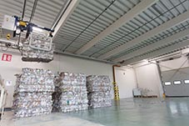
((PM_FEFCO_Tech_Seminar_2021-1.jpg))
Waste disposal lines from Hunkeler Systeme AG are highly automated, from the transfer of waste to the shredding process, to compaction in balers, to the gantry crane that places the bales in intermediate storage.

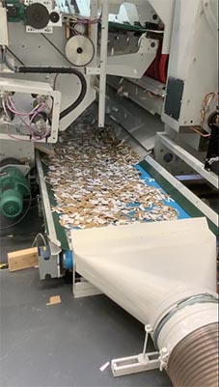
((PM_FEFCO_Tech_Seminar_2021-2.tif))
The interfaces from the die-cutting machine to the disposal system are integrated into existing technology structures in a space-saving manner.

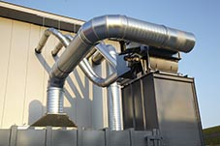
((PM_FEFCO_Tech_Seminar_2021-3.jpg))
The Greenline Concept from Hunkeler Systeme AG reduces energy consumption by up to 40 percent compared to systems that operate permanently at the same output.
About Hunkeler Systeme AG
Hunkeler Systeme AG, domiciled in Wikon (Switzerland), develops and builds waste disposal systems of various sizes. The systems range from small baling presses and press containers, to large extraction and compaction systems, to high-security systems for the destruction of securities. The customers of the globally active Hunkeler Systeme AG include commercial and service companies, printers, packaging producers, waste material dealers, municipalities, wood, plastics and metal processing companies, major distributors and national financial institutions.
------------------------------------------------------------------------------------------------------------------------------
For more information, please contact:
Hunkeler Systeme AG
Erich Hodel
Industriestrasse 2
4806 Wikon / Switzerland
Phone +41 62 745 77 77 (head office)
www.hunkelersysteme.com
------------------------------------------------------------------------------------------------------------------------------

